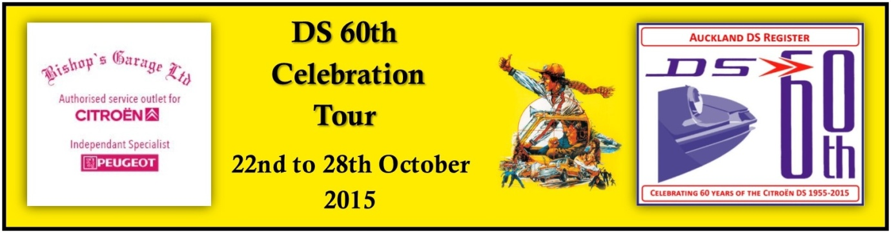

DAY ONE DS 60th CELEBRATION TOUR/ TOURTIERE ADIEU
Friday 23 October 2015.
Day’s Details.
1. Gather at The Northener Hotel carpark around 8.00am. Our main concern today is to arrive at Auckland well before the holiday rush hour grinds to a halt.
2. Depart Kaitaia on the first section of the day’s drive. As most will have travelled to Kaitaia via the Mangamuka Gorge we will be travelling down the East Coast highway. We plan to bypass most towns on the way south however you can visit any town you wish. Kerekeri and Whangarei will be among the towns the route that we will bypass.
3. The first leg will finish at Waipu which will be our lunch and rest stop.
4. After lunch we begin the second leg of the tour. We will proceed south on Highway 1, right through to the start of the Northern motorway at Johnson Hill. If you do not wish to pay a toll you can leave HW 1 just before you reach the Johnson Hill tunnels, and proceed through Waiwera, Orewa and re-join the motorway at Silverdale.
5. From Johnson Hill Tunnels we will stay on the motorway until you leave it at exit at exit 432, Drury. The Drury Motor Lodge is approximately 1km on the left. Those who plan to overnight elsewhere will of course leave the tour as it best suits them.
6. For those staying in Drury will arrange a meal either at the local Tavern or a local restaurant.

